Webinar 1 – 09/16/2020

Name:
School and/or District:
Role:
Math Certified:
ESE Certified:
Somebody that I am collaborating with (including contact information):

Using data is vital to getting back on track/focus…

 | During Webinar – Ideas From Peers:  Participate and take notes during the Breakout Session here… | Planning: What do I/we want this to look like in my/our plan?
How is data being used district-wide and at the school-level?
How are you involved in data analysis at the district/school/grade/classroom level?
What data have you been using?
Sources?
How often?
What positives have come out of the experience? Barriers?
What are the roles of the members on your collaborative team that review data?
How are you collecting and using data in the 2020-2021 school year (brick and mortar vs. innovative models)? How is this different from past school years?
What data collection/use ideas can you share?

Following the webinar, please take some time to think about the questions below regarding your current way of work and the information that you still need to plan.
Post-Webinar “Think-Abouts”
What formative assessments are done to obtain useful math data?
Do you plan horizontally? If so, who is on the team and how often do you meet?
Do you plan vertically? If so, who is on the team and how often do you meet?
What information do you still need?

Webinar 2 – 10/21/2020
 | During Webinar – Key Points:  Participate and take notes during the Panel here…  What are your take-aways pertaining to the way data is being shared with parents? | Planning: What do I/we want this to look like in my/our plan regarding sharing data with our parents?
Questions for Parents:
- Why is it important to empower parents/families to understand the importance of grade-level expectations in math?
- Why is it important to parents/families to understand the implications of how their child’s district/school/teacher assesses what their child is learning and the level of learning in math?
- What data does your child’s school share with you? What do you share with the school? What would you like to share with your child’s school? What would you like for them to share with you?
Questions for Educators:
- How do you empower parents/families to understand the importance of grade-level expectations in math?
- How do you empower parents/families to understand the implications of how their child’s district/school/teacher assesses what their child is learning and the level of learning in math?
- What data do you share? Screening data and diagnostic data? Tiered instruction/intervention data? (e.g., How do you use iReady/STAR data?)

Post-Webinar “Think-Abouts”
What is your district/school plan to communicate with parents?
How will you be changing your practices based on the information that you have received from parents/families?
Time to collaborate: Please identify a peer from another school/district/grade and add their responses to the above (two) questions.
1.
2.

Webinar 3 – 11/18/2020
 | During Webinar – Key Points:  Participate and take notes during the session here…  What are your take-aways pertaining to data use and maximizing the potential for all students? | Planning: What do I/we want this to look like in my/our plan?
Slide 15: Guiding Questions
- How are course placement decisions made in your district (from elementary to middle, middle to high, and to postsecondary)?
  - Who is involved in making those decisions? How can we hold them accountable from elementary to postsecondary?
- How do student data drive course placement decisions?
  - What is the impact of course placement on student success in middle grades, secondary, and postsecondary?
- How can we use data to ensure our pathways maximize student potential for all students?
  - What data are essential to determining the effectiveness of your district’s math pathways?
- How do you look at data: individually or holistically?
  - How will comparing individual data to the larger group help improve mathematics instruction for all students?
 | During Webinar – Key Points:  Participate and take notes during the session here…  What are your take-aways pertaining to data use and maximizing the potential for all students? | Planning: What do I/we want this to look like in my/our plan? How will I/we use FDOE data resources to identify trends to facilitate conversations about successes and barriers to assist in problem-solving areas of need?
EduData
EDStats
Florida School Grades
Report Card

Post-Webinar “Think-Abouts”
Create your SWOT with your data team.

Reflect on your SWOT with your data team.
- What changes would you consider to strengthen the weaknesses within your math pathways?

- How can you capitalize on the opportunities and eliminate the threats?

Webinar 4 – 01/20/2021
During Webinar – Key Points: Participate and take notes during the session here…
What are your take-aways from the discussion with the panelists?
Problem Identification: | Problem Analysis:
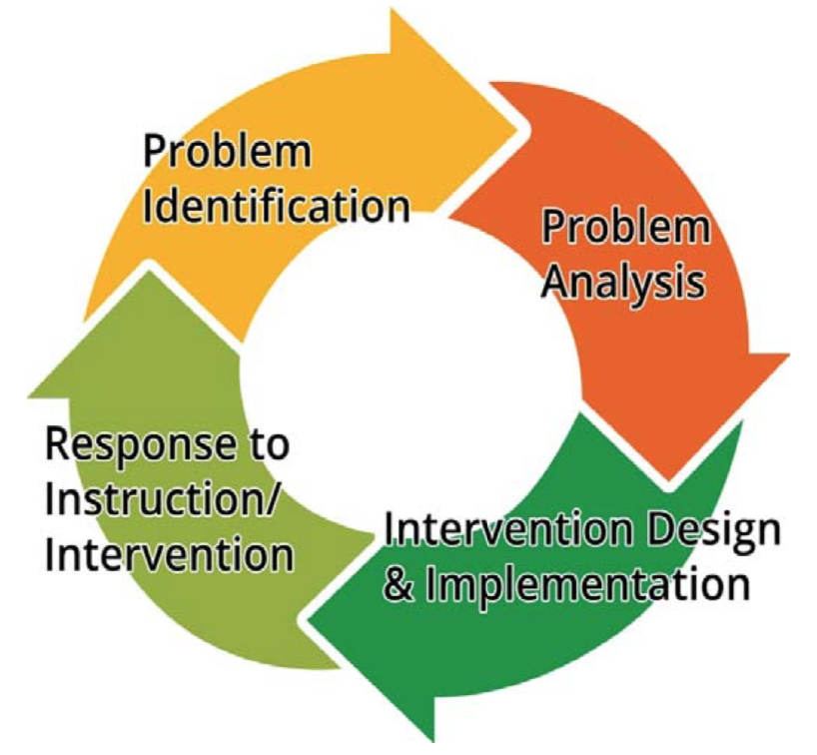
Response to Instruction/Intervention: | Intervention Design & Implementation:
Post-Webinar “Think-Abouts”
Planning: What do I/we want this to look like in my/our plan?
- How are your school’s/district’s math goals developed and communicated with stakeholders (who are they)?
- Does your school’s SIP have math goals identified?
- How do the goals address and impact students with disabilities?
- How are the math goals monitored (summative, interim)?
- What progress monitoring data will measure the impact on students (what program/tool/assessment/source)?
- How will the information inform instruction? (Does the school/district allow collaborative planning time for coaches/teachers?) (Do you discuss data with your students/parents and what impact does it have on their performance and the math goals that are made?)
- Are there additional goals that you feel need to be included?

Webinar 5 – 02/17/2021
During Webinar – Key Points: Participate and take notes during the session here…
What are your take-aways from the discussion with the panelists?
 | During Webinar – Key Points:  Participate and take notes during the Panel here…  What are your take-aways pertaining to the ways parents are empowered? | Planning: What do I want this to look like in my plan regarding empowering parents?
How do you empower parents/families to:
- Contribute to the identification of focused district goals for improving instruction and achievement in math?
- Support the district/school in reaching district/school-wide goals in math?
- Participate in activities related to school-level strategies designed to reach district/school goals in math?
- Understand the relationship between their child’s classroom instruction and school-level strategies designed to reach district/school goals in math?
- Offer feedback to school and district officials on the relevance of district goals and school-level strategies in meeting their child’s instructional needs in math?

Follow-up

Follow-up Activity for INSERVICE POINTS:
Outlined below are the required steps to complete the follow-up activity and submit it for verification to your principal or supervisor.
- Complete the Collaborative Math Plan (during/in-between webinars)
  - Option 1: Collaborative activity with a peer from another district
  - Option 2: Collaborative activity with a peer from within your district
- Follow-up activity
  - Presentation of information to supervisor regarding what you have learned from the webinars and share plan for verification
    - Use your notes from the Planning column to complete the Math Action Plan template that will be provided following the final webinar
  - Have your principal/supervisor sign and date, acknowledging that she/he has reviewed your webinar notes and Math Action Plan
- Submit the form to srobertson@usf.edu

